Date | 30 September 2026
Team ID | 6ab4dd7a6f290be8a6b49f92
Project Name | Script-Controlled ACL – Restrict Record Access Based on Field Value
Maximum Marks | 3 Marks

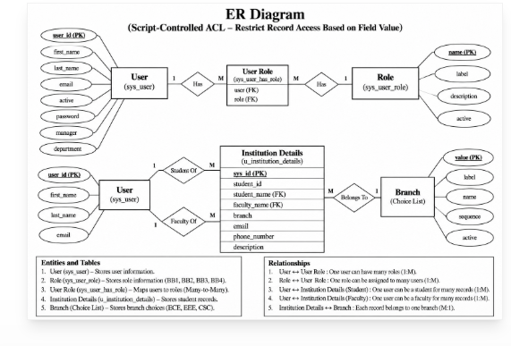
The Entity–Relationship (ER) Diagram represents the structure of the Institution Details data used in the ServiceNow project. The main entity contains attributes such as Student ID, Student Name, Faculty Name, Branch, Email, Phone Number, and Description. The Branch attribute stores values such as ECE, EEE, and CSC and is the key field used by the Script-Controlled ACL to determine record access. User and role information is associated with the access-control mechanism, where roles such as BB1, BB2, BB3, and BB4 determine the permitted Read, Create, Write, and Delete operations.

